

CS 305 Project Two
Practices for Secure Software Report

Table of Contents

Document Revision History 3
Client 3
Instructions 3
Developer 4
1. Algorithm Cipher 4
2. Certificate Generation 4
3. Deploy Cipher 4
4. Secure Communications 4
5. Secondary Testing 4
6. Functional Testing 5
7. Summary 5

Document Revision History

Version | Date | Author | Comments
1.0 | 8-13-2022 | James Carver

Client



Instructions

Deliver this completed Practices for Secure Software Report documenting your process for writing secure communications and refactoring code that complies with software security testing protocols.
Respond to the steps outlined below and replace the bracketed text with your findings in your own words. If you choose to include images or supporting materials, be sure to insert them throughout.

Developer
[insert name here]

1. Algorithm Cipher
Determine an appropriate encryption algorithm cipher to deploy given the security vulnerabilities, justifying your reasoning. Be sure to address the following:

- Provide a brief, high-level overview of the encryption algorithm cipher.
- Discuss the hash functions and bit levels of the cipher.
- Explain the use of random numbers, symmetric vs non-symmetric keys, and so on.
- Describe the history and current state of encryption algorithms.

The SHA-256 algorithm was created by the National Security Agency in 2001. The hash function outputs a 256 bits long value. As of 2021, “SHA-256 is one of the most secure hashing functions on the market. The US government requires its agencies to protect certain sensitive information using SHA-256”. 2²⁵⁶ or 1.15_{E}84 attempts would need to be made by brute force to decrypt the data. SHA-256 has no known collisions as of 2021.

Hash keys are a way to ensure data integrity in public key cryptography. “One purpose of a hash function in cryptography is to take a plaintext input and generate a hashed value output of a specific size in a way that can’t be reversed” (Crane 2021). It takes the original message and encrypts it and gives it a hash value. When that message is received, that value is used to see if anything was changed in the message from a third party. Any change in the message will result in a new hash key that will not match the original.

In symmetric encryption, a single key is shared between all parties involved. It is less secure than Asymmetric as everyone involved must keep the key secure. Asymmetric uses two keys, one for encrypting and one to decrypt. The first is a public key that everyone has access to. The second is a private or secret key that is only known by the parties involved. Random numbers aid in the encryption of data by making it look like the numbers mean nothing. This can be accomplished by using a cryptographic pseudorandom number generator.

One of the most known historic encryption devices is the Enigma used in WWI. Breaking the Enigma saved millions of lives. Today we use encryption to save lives and protect against attacks both physical and cyber. Encryption algorithms such as AES, RSA, RC2, RC4, RC5, DES, Blowfish, ECIES, and ARCFOUR are strong, ever evolving, and changing to help in that mission. But with that, hackers are also ever evolving and changing to fight against them.

2. Certificate Generation
Generate appropriate self-signed certificates using the Java Keytool, which is used through the command line.

- To demonstrate that the keys were effectively generated, export your certificates (CER file) and submit a screenshot of the CER file below.

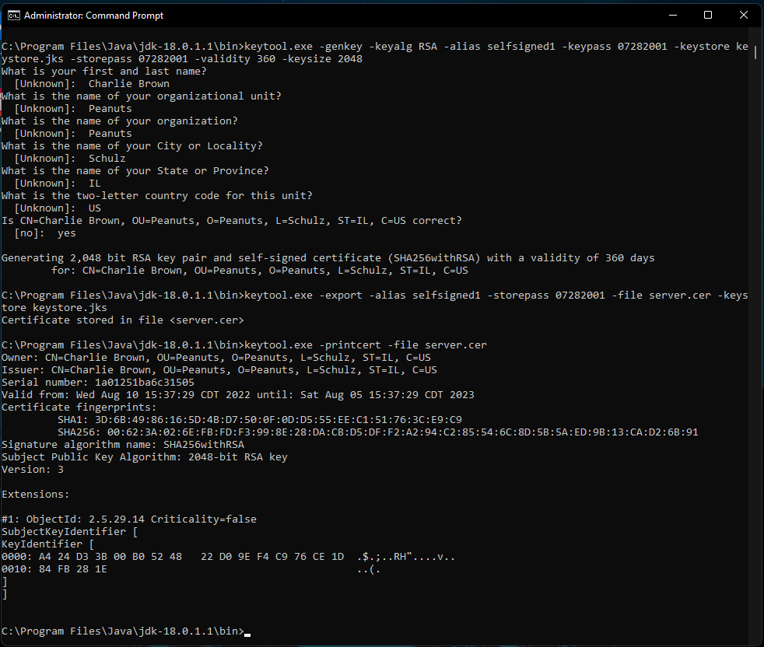

3. Deploy Cipher
Refactor the code and use security libraries to deploy and implement the encryption algorithm cipher to the software application. Verify this additional functionality with a checksum.

- Insert a screenshot below of the checksum verification. The screenshot must show your name and a unique data string that has been created.

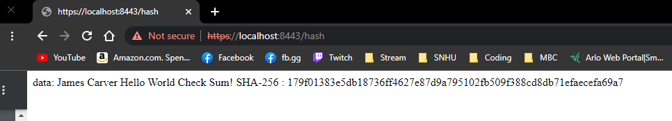

4. Secure Communications
Refactor the code to convert HTTP to the HTTPS protocol. Compile and run the refactored code to verify secure communication by typing https://localhost:8443/hash in a new browser window to demonstrate that the secure communication works successfully.

- Insert a screenshot below of the web browser that shows a secure webpage.

The screenshot shows that the webpage was accessed using the https. It also shows that there is an error in the trusted certificate. I made multiple attempts to add the certificate to the trusted store but could not get it to work properly. Here is the error when “Not secure” is clicked

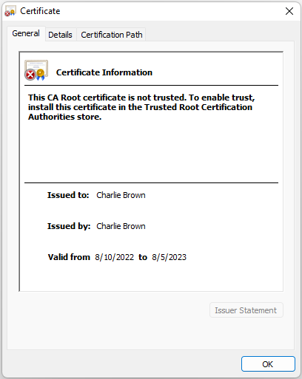

5. Secondary Testing
Complete a secondary static testing of the refactored code using the dependency check tool to ensure code complies with software security enhancements. You only need to focus on the code you have added as part of the refactoring. Complete the dependency check and review the output to ensure you did not introduce additional security vulnerabilities.

- Include the following below:
  - A screenshot of the refactored code executed without errors
  - A screenshot of the dependency check report
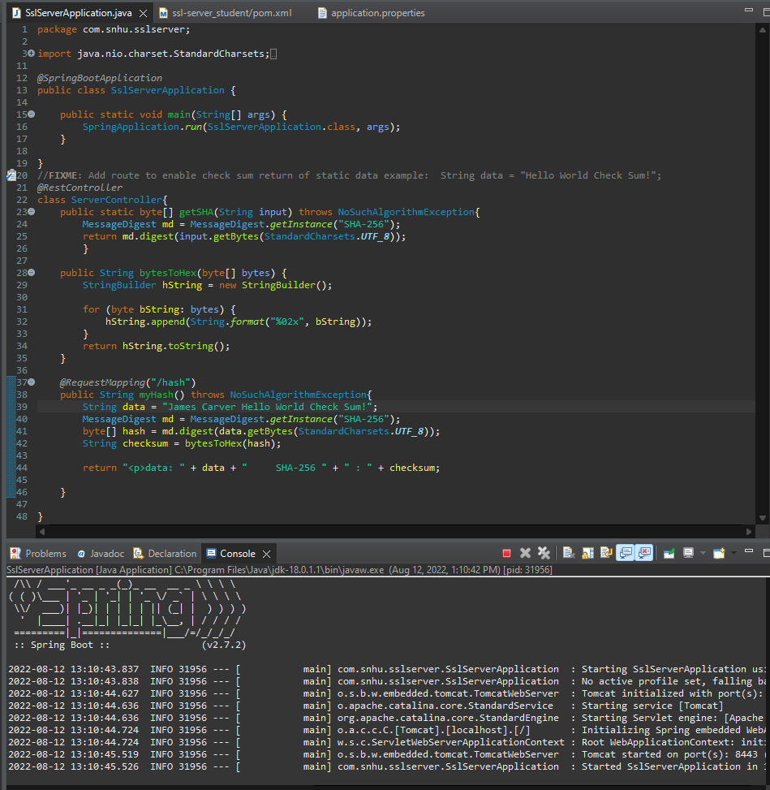

This screenshot is the code executed as it was given to us.

6. Functional Testing
Identify syntactical, logical, and security vulnerabilities for the software application by manually reviewing code.

- Complete this functional testing and include a screenshot below of the refactored code executed without errors.
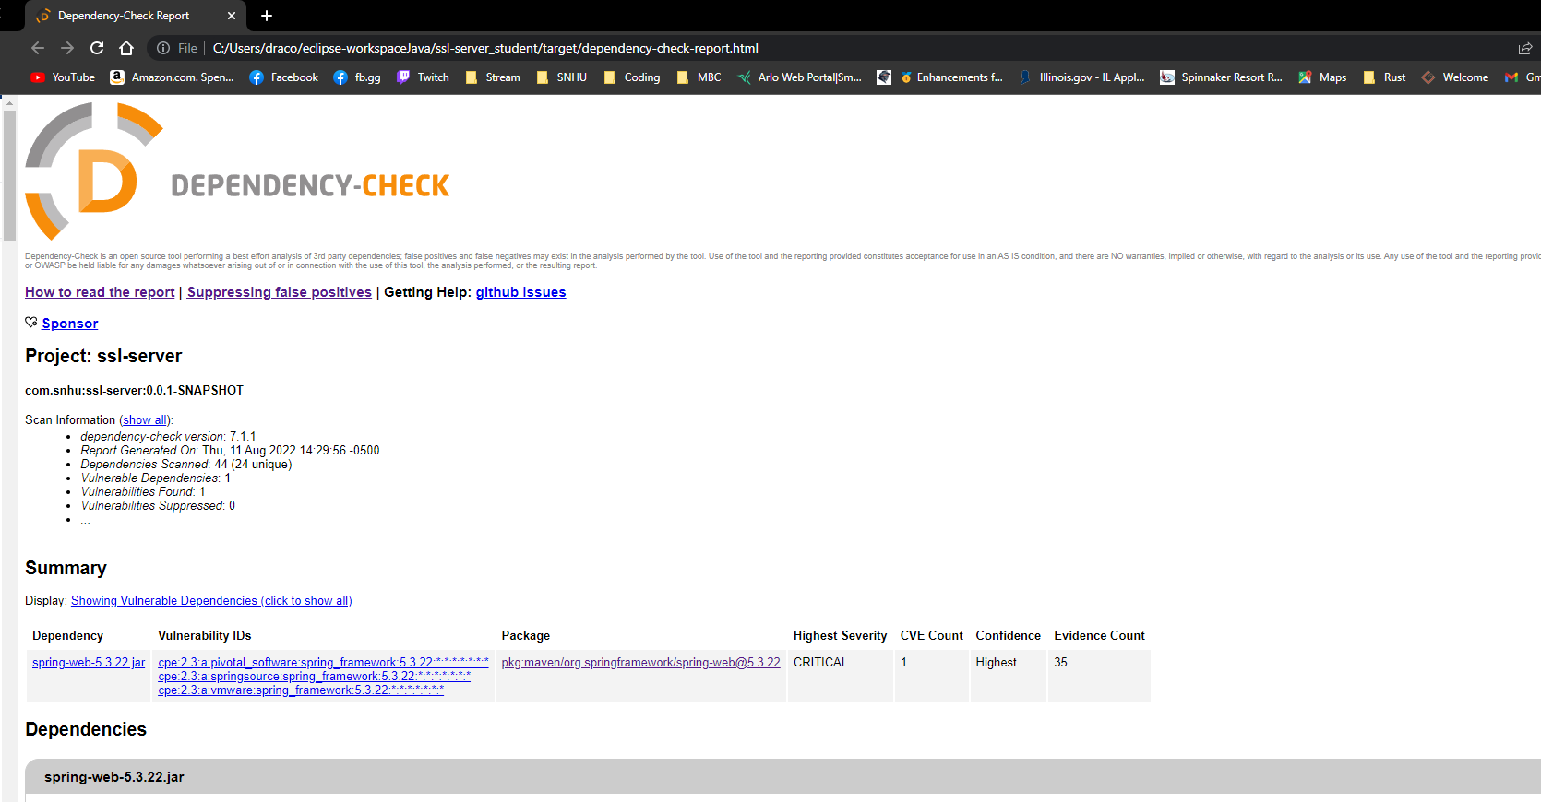
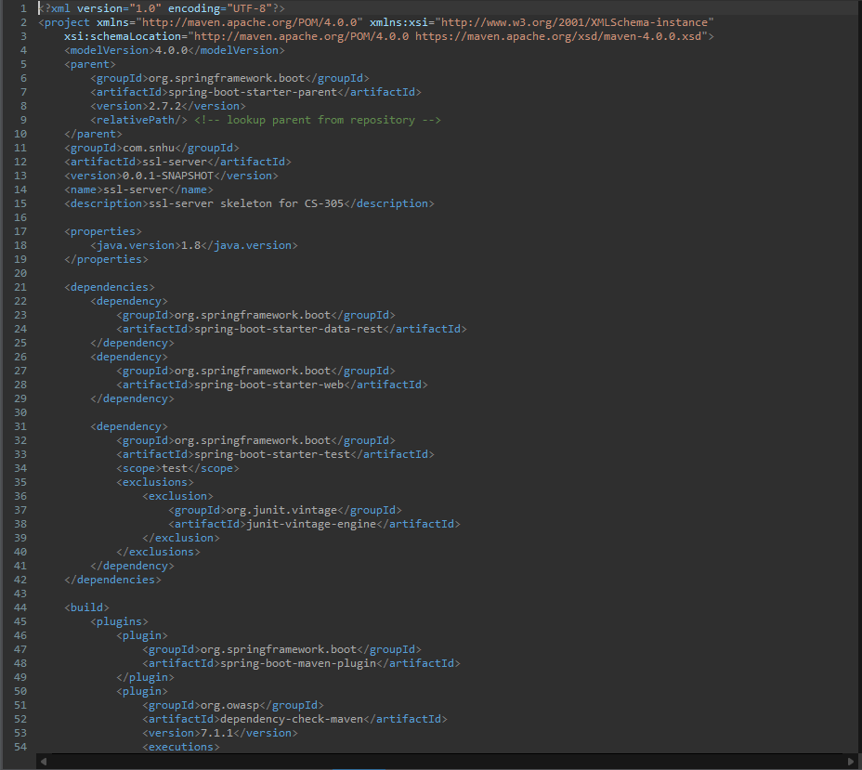

7. Summary
Discuss how the code has been refactored and how it complies with security testing protocols. Be sure to address the following:

- Refer to the Vulnerability Assessment Process Flow Diagram and highlight the areas of security that you addressed by refactoring the code.
- Discuss your process for adding layers of security to the software application and the value that security adds to the company’s overall wellbeing.
- Point out best practices for maintaining the current security of the software application to your customer.

The code was refactored to include the latest version of spring-boot-starter-parent and dependency-check-maven. Both versions were out of date. By updating those two it removed 12 vulnerabilities.

After referring to the Vulnerability Assessment Process Flow Diagram I addressed four areas of security.

- Cryptography
- APIs
- Code Quality
- Client/Server

We added security to the software application by using a signed certificate and keys that aloud us to connect with 256- bit encryption. This level of security helps maintain secure communications between client and server. Maintaining high security in the application will help protect the company's assets along with keeping their clients’ trust and business. The best practice to provide current security is to regularly check the code for vulnerabilities. After implementing new functions or changing current ones if any new vulnerabilities are found the development team should work on eliminating them. Some vulnerabilities that have no solutions should be analyzed to decide if those vulnerabilities impact the application.

References
Crawford, D. (2019, February 4). How does AES encryption work? ProPrivacy.Com. Retrieved July 20, 2022, from https://proprivacy.com/guides/aes-encryption#:%7E:text=AES%20is%20a%20symmetric%20key,choice%20by%20just%20about%20everyone.
Crane, C. (2021, January 25). What Is a Hash Function in Cryptography? A Beginner’s Guide. Hashed Out by The SSL StoreTM. Retrieved July 20, 2022, from https://www.thesslstore.com/blog/what-is-a-hash-function-in-cryptography-a-beginners-guide/#:%7E:text=Hash%20functions%20are%20a%20way,a%20means%20of%20identity%20verification.

